
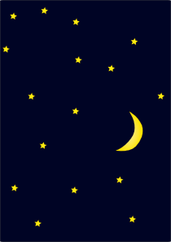
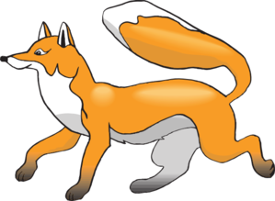
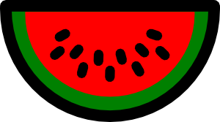


White is for cloud

englishelp.ru

Black is for night

englishelp.ru

Red is water melon

englishelp.ru

Yellow is lemon

englishelp.ru

Orange is fox

englishelp.ru
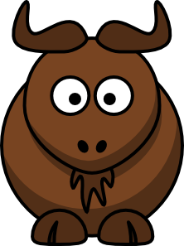
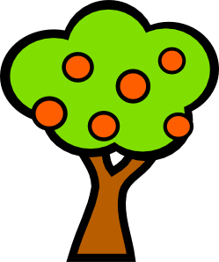

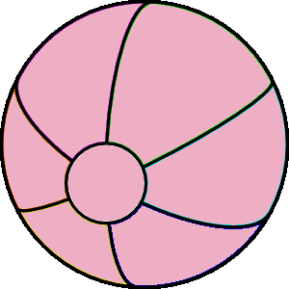

Brown is ox

englishelp.ru

Green is for tree

englishelp.ru

Blue is for sea

englishelp.ru

Pink is my ball

englishelp.ru

Now I know the colors all

englishelp.ru

