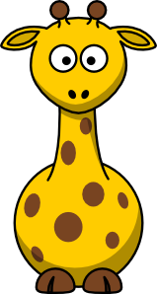

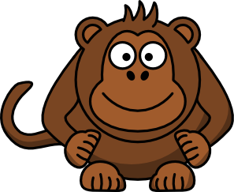
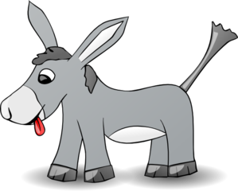

ONE giraffe

englishelp.ru

TWO fishes laugh

englishelp.ru

THREE monkeys

englishelp.ru

FOUR donkeys

englishelp.ru

In the Zoo I see

englishelp.ru
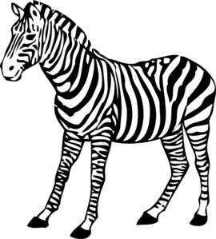



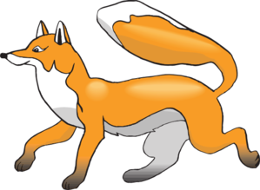


FIVE zebras
and a lion

englishelp.ru

SIX bears Himalayan

englishelp.ru

SEVEN very fatty hogs

englishelp.ru

EIGHT amazing hedgehogs

englishelp.ru

NINE foxes

englishelp.ru

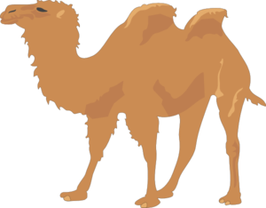


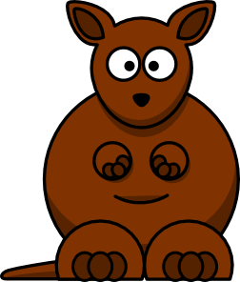
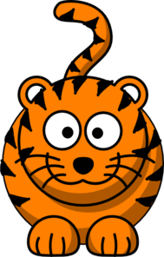
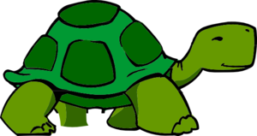


TEN camels
in the boxes

englishelp.ru

ELEVEN funny frogs

englishelp.ru

And TWELVE bushy dogs

englishelp.ru

And many-many kangaroos,
Tigers, turtles, hippos

englishelp.ru

